3.1 Networks

Network Fundamentals

3.1.1 Identity different types of networks

|  |  |  |  |
| --- | --- | --- | --- |
| Name | Definition / Feature | Pros and Cons | Technology |
| Local Area Network (LAN) | Connect computer systems, within a limited geographical area | High data transfer rates, Shrink of peripheral services (e.g. printer) | Hub/switch, Ethernet cabling |
| Wireless Local Area Network (WLAN) | Similar to LAN (2 or more systems within a limited geographical area);  Difference: wireless connection method, mobile devices (e.g. laptop) available | All of LAN’s; less secure (possible to have intruders since it is wireless) | Wifi (using radio waves); wireless hub/switch |
| Virtual Local Area Network (VLAN) | Used to partition the initial lAN - using *logical separate networks* (each cannot see shared resources on others) | Virtual groups, greater flexibility, safer resources (see the table on p133) | Hub/switch/router —  LSN1(client client server)  LSN1(client client server)  etc. |
| Wide Area Network (WAN) | Within a large geographical area e.g. Internet;  Consists of LANs connected overthink over a broad geographical area |  |  |
| Storage Area Network (SAN) | Make large storage devices accessible from server in a convenient and easy way  e.g. disk arrays, tape libraries | Connects the servers to the storage devices - enough storage space to compete their tasks;  Prevent data loss | Which and ethernet cabling etc. |
| Intranet | A collection of private computer networks within a company, school or organization that utilized standard network protocols e.g. TCP/IP;  Private analogy of Internet | Facilitate communication between individuals or work groups; Improv data sharing; Resources not available to the outside world;  Firewall protect the intranets connected to the Internet |  |
| Internet | Global WAN - connecting millions of computer systems; Connects a large number of networks, the largest WAN | World Wide Web is a service of the Internet, consisted of websites and supports for email etc.;  Decentralized - resources not controlled by a single server, each computer system is a server of its own: independent and shares services with global Internet community | Access to the Internet goes through a commercial Internet Service Provider(ISP);  Not owned by a single entity |
| Internet of Things (IoT)  ? | Net work of individual “things” connect to the Internet, communicate and exchange data |  |  |
| Extranet | A computer network, utilize the Internet to allow controlled access by specific users to a specific LAN or WAN;  Intranets partially accessible to authorized outsiders | Security and privacy, pubic and outside users are not permitted to access any secure data (only access a limited amount of data | Firewall controls the access rights and allows access to etc intranet only to authorized ones |
| Virtual Private Network (VPN) | Similar to LAN or WLAN; Allows cleanest from remote locations t connect and paper to be inside the LAN as if physically present | LAN’s benefits (share data and resources without compromising security); Securely and cost-effectively connect geographically disparate offices of a business within a network with all the functionalities of a single LAN |  |
| Personal Area Network (PAN) | Interconnects devices centered around an individual person’s workspace; LAN supporting one person;  Short range covered (10m) |  | Bluetooth technology |
| Peer-To-Peer (P2P) | Network not utilizing the client/server model (clients request resources and servers provide them);  Decentralized - all nodes and peers are both clients and servers at the same time |  |  |

3.1.2 Importance of standards in the constructions of networks

Purpose to have universal standards:

Otherwise having incompatible hardware or software

e.g. a computer system developed only supported USB ports, and a stick only supported Ethernet ports

Content of standards:

Describe the common ground on which hardware and software manufactures can depend on in order to build systems that are able to communicate with each other

Importance of standards:

To provide a common international “language” that enables compatibility for all computer systems throughout the globe

3.1.3 Networks, communication and layers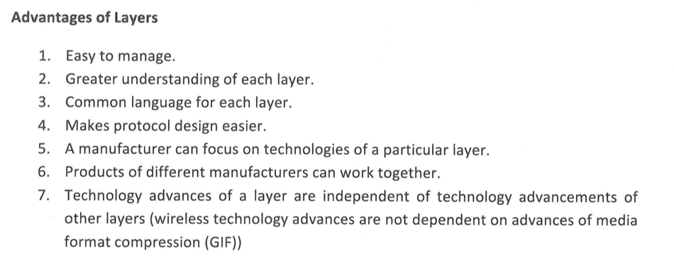

OSI (reference model) - Open Systems Interconnection model

Main points:

Established by International Standard Organization (ISO)

Aim: to facilitate communication across a variety of systems

7 layers

Abstract depiction and explanation of the network communication process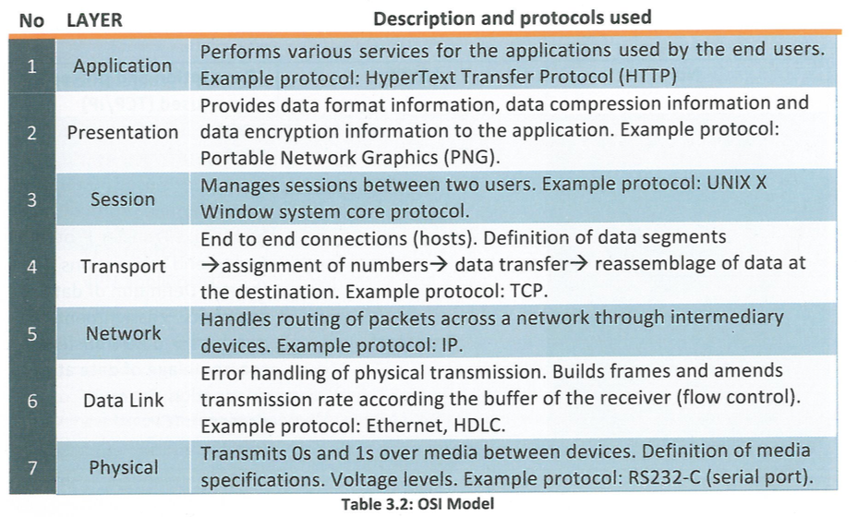

TCP/IP (protocol model) - Transfer Control Protocol / Internet Protocol

Main points:

Hierarchical model protocol

Represents all functionality required foe successful communication between users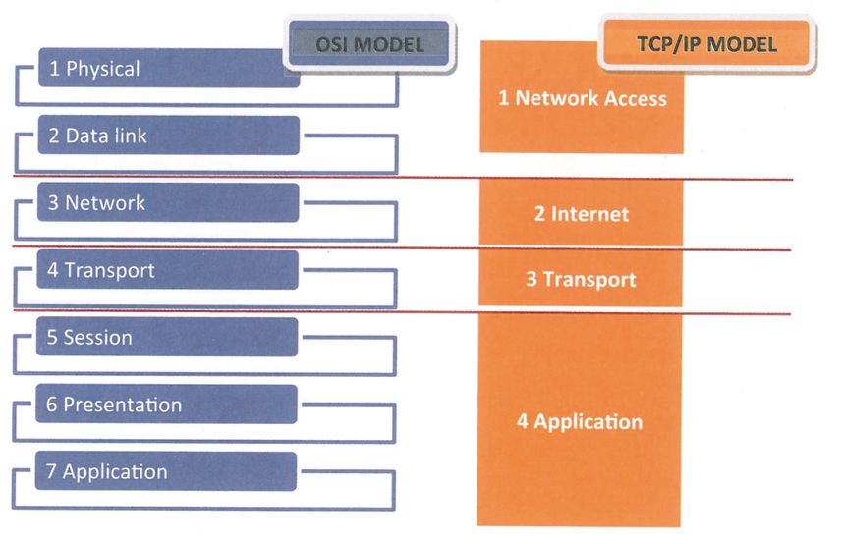

3.1.4 Technologies required to provide a VPN

Main points:

Virtual Private Network (VPN)

“tunnelled" network connection through the Internet or any other public network

Ideal for establishing a secure connection between prove networks with remote users and remote sites

Exchange data across the internet as if it was directly connected to a private network

VPN technologies

1. Hardware and software requirements

Internet access, VPN software, VPN routers, VPN appliances, VPN concentrators, VPN servers

1. Secure VPN

Traffic on VPN must be encrypted, authenticated and sent along virtual tunnels

Internet protocol security protocol (IPSec) functions in both transport and tunnel mode

SSL 3.0 or TLS with encryption

1. Trusted VPN

All traffic on the VPN relies on the security of a provider’s network to protect the network

“layer 2” and “layer 3” VPNs

1. Hybrid VPN

A combination of both secure and trusted technologies or a combination of two VPN technologies

Common VPN types:

1. Site-to-site VPN

Connects entire networks and facilitates secure data interchange between different sites

1. remote-access VPN

Connects individual hosts to private networks and facilitates teleworkers who need to access their company’s network securely using the Internet

3.1.5 Use of a VPN

VPN benefits (crucial ones listed here):

1. Easier communication
2. Take advantage of the Internet to provide secure connection
3. Decrease operational costs
4. Extends connections across numerous geographic sites
5. Improves overall productivity
6. Improves security
7. Offers flexibility to employee to take advantage of the company’s Intranet over and existing Internet connection; and to remote offices
8. Global networking opportunities
9. Simplifies network topology for administrators and companies (what is topology?)
10. Positive changes in working patterns